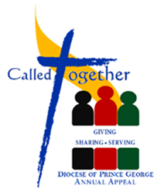
Commitment Weekend
Pledge Form Distribution and Instructions
Sep 29 – 30, 2018

Reader: Good evening/morning. It is Commitment Weekend for Called Together, Giving, Sharing, Serving in all parishes throughout our Diocese.
At this time I would like to invite the designated ushers to come forward and to distribute the pledge forms and pencils. I ask that one representative from every household take one form and a pencil. Thank you.
Instructions for Reader: (wait a few minutes until almost everyone has form then continue.)
Reader: Please fill in your name, address and phone number.
Instruction for Reader: (wait a few seconds)
Reader: Once you have decided on the total amount of your pledge, please write that amount one the line next to “Pledge Amount”.
For those who have already made, or sent your donation thank you, and please write any of the following:
- Already pledged (2) Already donated (3) Prayers

Instruction for Reader: (wait a few seconds, once you see that almost everyone is done, read out the following)
Reader: I would like to ask the ushers to collect all pledge forms and pencils. Thank you.
On behalf of Bishop Jensen and those in our diocese who benefit from your generosity, thank you.
I also take this opportunity to thank those of you who have already made your commitment to Called Together – Giving, Sharing, Serving.

