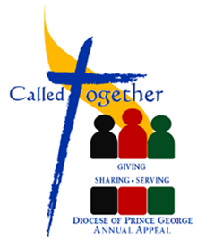
Kick Off Weekend
September 8—9, 2018

Instructions for Kick-off
- Add the bulletin write-up in your bulletin—see below.
- Put out posters and envelopes for parishioners in foyer.
- Add any of the universal prayers provided below to your regular set of prayers
- Before the final blessing:
- read Bishop Stephen Jensen’s letter
- Show the Called Together video (It is also an option to show the video after a brief homily about the readings.)
- demonstrate what will be found in the envelopes (Bishop’s Letter; Called Together brochure; return envelope with pledge form.)
- Ask parishioners to pick up their envelope. If they do not have a personalized envelope they are welcome to take a blank one provided.

ADDITIONAL NOTE: The video for the Appeal has been sent in USB and DVD.

Bulletin Write-Up (please adapt as needed)
Along with all other parishes and missions throughout the diocese, today we kick-off the Annual Diocesan Appeal: “Called Together: Giving, Sharing, Serving.”

Called Together supports the mission of our local Church across our diocese. Your gift to Called Together is one way that you can practice stewardship and participate in the mission of the Church.

You are invited to participate in this task in providing for the needs of our Diocesan church.
Our Parish Goal is: $__________

For the pulpit announcement (please read)
Letter from Bishop Stephen Jensen

Universal Prayer
- For our Diocesan family, as we begin our Annual Appeal - Called Together: Giving, Sharing, Serving; that we will unite in supporting the needs of our Diocese. We pray to the Lord.

- For our Diocesan family, as we begin our Annual Appeal - Called Together: Giving, Sharing, Serving; that our eyes and ears will be open to the needs of our Diocese. We pray to the Lord.

