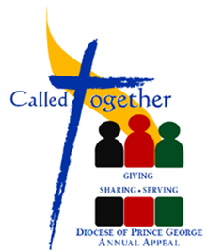
Education Weekend
September 15—16, 2018

Includes the following:

- Lay Witness Presentation
- Bulletin write-up that includes parish goal and current update
- A parish specific pulpit announcement
- Universal Prayer – please see below

Bulletin Write-Up
TODAY is the Educational Weekend for Called Together – Giving, Sharing, Serving. As in the past, your pledge truly benefits the programs and ministries throughout our Diocese.

Our Parish Goal: $__________

Pulpit Announcement (please adapt as needed)

TODAY is the Educational Weekend for Called Together – Giving, Sharing, Serving.

(If you have a lay witness to share a testimony about the benefits of the Appeal, please let him/her speak after Prayer After Communion.)

If you do not have a lay witness to share a testimony, please ask at least two readers to read the content of this year’s Called Together brochure.) After reading the content of the this year’s brochure, continue with the following announcement:

The Diocesan goal for Called Together is $ 400,000 and our parish goal is $________________.

One way in which we can live a stewardship lifestyle is through our support to “Called Together – Giving, Sharing, Serving.” With your support, you are serving the material and spiritual needs of our diocesan community. Let us remember our Lord Jesus himself calls us to be generous with all the gifts God has given us, to grow them and return them with increase.

Thank you to those who have already given their support to Called Together and let us continue to pray for its success.)

Universal Prayer
For our Diocesan family called to support the ministries of our Church through the Annual Appeal - Called Together: Giving, Sharing, Serving; that our faith will be shown as we reach out to meet the needs of others. We pray to the Lord.

For our Diocesan family called to support the ministries of our Church through the Annual Appeal - Called Together: Giving, Sharing, Serving; that our generosity will reflect our desire to be followers of Christ. We pray to the Lord.

