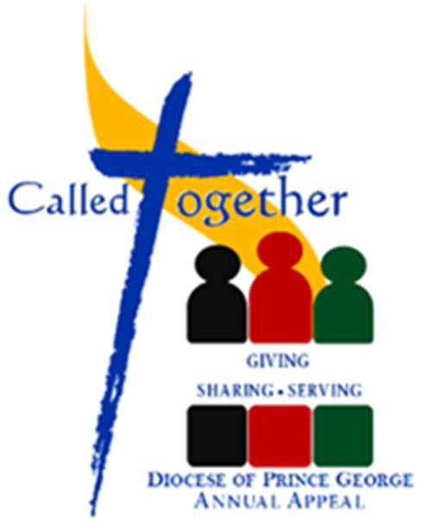
KICK OFF WEEKEND
SEPTEMBER 9—10, 2023

Instructions for Kick-off
IN RESPONSE TO FEEDBACK FROM THE PARISHES, THERE IS NO VIDEO FOR THIS YEAR’S APPEAL.

A copy of the initial Appeal Update is attached to the Wednesday Weekly and sets out the parish goals. It has not yet been updated with donations received after July 1^{st.}

- Add the bulletin write-up in your bulletin—see below.
- Put out posters and any envelopes for parishioners in foyer.
- Add any of the universal prayers provided below to your regular set of prayers
- Before the final blessing, please read Bishop Jensen’s letter from the brochure
- Ask parishioners to pick up their envelope. If they do not have a personalized envelope they are welcome to take a blank one provided.

Please advise parishioners that those who donate by Interac eTransfer should include a message with the name of your parish that should be credited with the donation, any instructions regarding allocation of funds to Called Together and Healing and Reconciliation, as well as an email address in case we have any questions about the donation. Donors can also include their donor number, which is found on the outside of their envelope.

Bulletin Write-Up (please adapt as needed)

Along with all other parishes and missions throughout the diocese, today we kick-off the Annual Diocesan Appeal: “Called Together – Giving, Sharing, Serving.” Called Together supports the mission of the local Church across our diocese. Your gift to Called Together is one way that you can practice stewardship and participate in the mission of the Church. The diocesan goal has been slightly increased to $275,000 this year, still far short of the usual $400,000. This year, we are putting a focus on funding those programs which were suspended under COVID, but are now coming back to life. We also continue to direct the biggest portion to go to help those smaller parishes and missions across the diocese who continue to face ongoing challenges and need our support. Our Parish Goal is: $_____________ of which $____________ goes to support ministries throughout the diocese and $__________ goes to important projects within our parish. This year, the diocese is continuing to collect funds for the BC Bishops’ appeal in support of Healing and Reconciliation. This appeal is separate from Called Together and aims to provide funds for projects that support healing and reconciliation between indigenous and non-indigenous peoples. In prior years, the diocese has tried to meet this need through programs such as Returning to Spirit, the Rose Prince Pilgrimage and through the work of our priests and religious involved in indigenous ministry. After we began our first Healing and Reconciliation Appeal, the Canadian Bishops agreed to support a national campaign to raise $30 million dollars in support of healing and reconciliation efforts. The diocesan goal for our portion of that $30 million is $147,000 of which $110,000 has already been raised. The monies raised in our diocese will be used to support healing and reconciliation efforts in our diocese. The committee tasked with discerning how to best use those funds has already begun to meet. We look to the generosity of everyone to make a meaningful contribution to promote this important work. The form in the Called Together package allows you to designate how much you would like to direct to the Diocesan Annual Appeal and how much to the Healing and Reconciliation appeal. We thank you for your continued generous support.

For the pulpit announcement (please read this letter from Bishop Jensen taken from the brochure)

Through the Annual Appeal over the last few years, the community of the diocese has responded to the extraordinary situation of small parishes and missions that suffered disproportionately due to the financial impact of the pandemic restrictions.

Now that we are returning to more normal conditions and people can once again participate in parish life, the Appeal focus can turn to ministries that were either suspended or curtailed during the health emergency. This includes work with youth and young adults and university students, hospital ministry, the Rose Prince pilgrimage and other forms of evangelization and outreach.

The overall Appeal goal has risen, a step towards a return to pre-pandemic levels of support. In addition, the Appeal includes a new category for parish projects. The Appeal infrastructure provides an efficient means for each parish to address its own needs and over the last few years several parishes have taken advantage of this opportunity.

Who could have predicted recent history? Times have changed, but our need to be stewards of God's blessings to us is constant. I invite you to join me once again in supporting the Annual Appeal to build the community of faith, service and witness in our local Church.

+Most Reverend Stephen Jensen
Universal Prayer – please select one of the first two in addition to the third prayer.

1. Option A. For our Diocesan family, as we begin our Annual Appeal: Called Together, that we will unite in supporting the needs of our Diocese. We pray to the Lord.

1. Option B. For our Diocesan family, as we begin our Annual Appeal: Called Together, that our generosity will reflect God’s generosity to us. We pray to the Lord.

2. For the BC Bishops’ campaign in support of healing and reconciliation; that the words of Jesus to us today will inspire us to live the humility of Christ through our support of the Indigenous communities in our province. We pray to the Lord.

