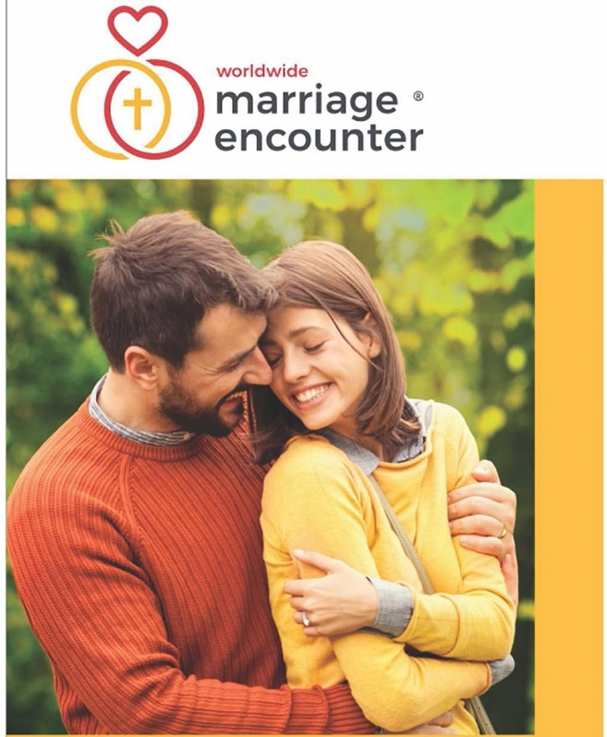
Uncover the secrets to a lasting, supportive, transformational marriage.
Even when a marriage is going smoothly, there are always opportunities to make it work better. The Marriage Encounter experience is a heart haven that helps
you listen, share, and connect more deeply. There is no group discussion. It’s just about the two of you learning to be the best, most loving and thriving couple you can be.

April 19 – 21, 2024
Virtual Experience
Edmonton based (Mtn Time)
Questions?
Doug & Candice Chappell
778-479-7900
Doug.candice.chappell@wwme.org
Apply at - wwme.org

Uncover the secrets to a lasting, supportive, transformational marriage.
The Marriage Encounter experience is a heart haven that helps you listen, share, and connect more deeply.
There is no group discussion. It’s just about the two of you learning to be the best, most
loving and thriving couple you can be.
April 19 – 21, 2024
Virtual Experience
Edmonton based (Mtn Time)
Questions?
Doug & Candice Chappell
778-479-7900
Doug.candice.chappell@wwme.org
Apply at – wwme.org

